# Royal Dutch Association for Aviation Department Parachuting

**Basic Safety regulations Sports parachuting 2024 Appendix B: Parachute Selection Rules Version 2**

According to BVR article 701 member 4 may a sports parachutist only jump of a main parachute that meets the requirements as stated in this appendix. In order to meet these requirements, three steps must be completed. This appendix only applies to square main parachutes.

Step 1: experience level by the sports parachutist

Sports parachutists become classified in seven experience levels. Determining before that is It total number of jumps. To reach a higher experience level the following requirements apply:

1. : fewer than 25 jumps
2. : 25 to 100 jumps, at least 10 jumps in the last 12 months
3. : 100 to 400 jumps; at least 25 jumps in the last 12 months
4. : 400 to 700 jumps; at least 50 jumps in the last 12 months
5. : 700 to 1000 jumps; at least 75 jumps in the last 12 months
6. : 1000 jumps or more; at least 100 jumps in the last 12 months
7. : 1200 jumps or more; at least 200 jumps On a cross braced parachute from category VI of which at least 100 in the past 12 months

Step 2: layout main parachutes

Each main parachute is classified in a certain categories (see BVR Attachment C, current version). This classification based on flight characteristics also runs from I to VII.

Which category main parachute used may become hangs off by It experience level: the main parachute category must not be higher than the experience level of the jumper.

Step 3: size and wing load main parachute

Also become to demand asked On the size by the main parachute and On the wing load.

|  |  |  |
| --- | --- | --- |
| Experience level | Minimal size (sqft) | Wingload maximum |
| I | 170 | 1,1 |
| II | 170 | 1,1 |
| III | 150 | 1,3 |
| IV | 135 | 1.5 |
| V | 120 | 1,7 |
| VI | No limit | No limit |
| VII | No limit | No limit |

The wing load is becoming calculated through the exit weight by the jumper (complete hung) in pounds (lbs) divided by the size of the main parachute (square feet, sqft). https://skydivekompasroos.nl/nl/ (not an official part of BVR)

About the layout by main parachutes in categories is becoming It management advised through the Material Commission. The list (BVR Appendix C, current version) is updated as often as necessary. To update by this list is **not** a separate Safety Bulletin needed. A current list of main parachutes are available on the website of the KNVvL Parachuting Department.

* (Yet) not classified non-crossbraced parachutes be able to Through a Chief Instructor may be temporarily assigned to a category of a comparable non-crossbraced main parachute based on information provided by the manufacturer.
* (Yet) not classified cross braced main parachutes traps to on It moment from automatic classification into category VII.

In the transition to a main parachute out a higher category or a main parachute of a smaller surface/larger wingload, it is strongly recommended to repeat the relevant canopy control jump tasks, as required for the A and B certificates, with the new main parachute.

A Chief Instructor may authorize a jumper to jump with a main parachute no smaller than one size, provided the jumper uses the applicable category and maximum wingload not exceeds. Of this serves the Chief Instructor a note at to make in It logbook and to make a written report to the board. When using a digital logbook, this will be recorded on the authority.

Jumped with a smaller main parachute (abroad or at a non-KNVvL center) than according to this attachment allowed gives be a KNVvL member no rights to jump with the relevant smaller main parachute.

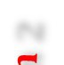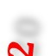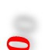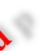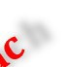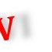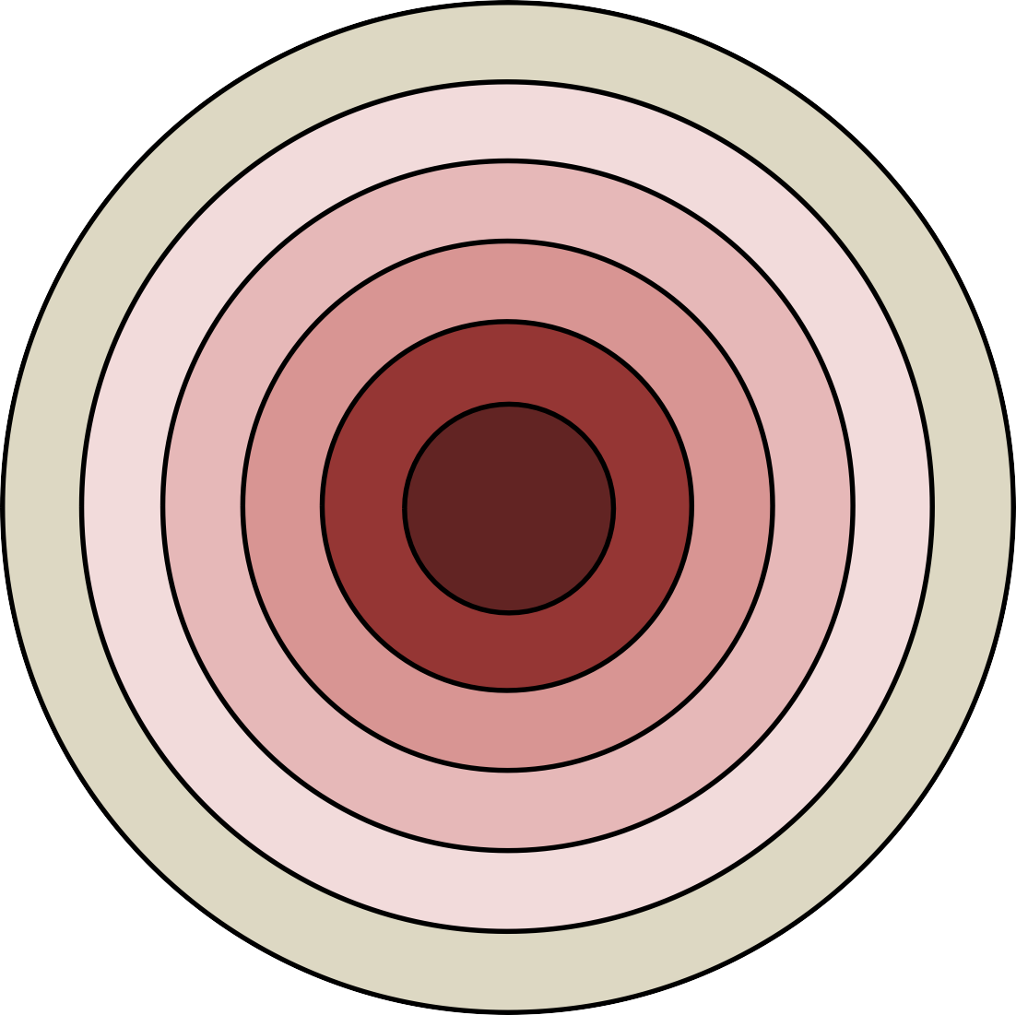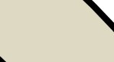

**N**

**Kompasroos**

**1200**

**1000**

**700**

**400**

**100**

**25**

IV

III

II

I

VII

VI

V

**C 100 75**

**50 25 10**

**1,1 1,1 1,3 1,5 1,7**

**170**

**W**

**170**

**150**

**135**

**120**

**A**

**N = Number of jumps (totaal aantal sprongen)**

**C = Currency (aantal sprongen in afgelopen 12 maanden) A = Area (oppervlak van de parachute in square feet)**

**W= Wingload (exitgewicht in pounds : oppervlak in square feet)**